# Lab09

### Exercise:

#### Problem 1:

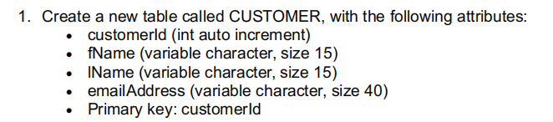

**Solution:**

**Code:** *create table if not exists customer(*

*customerId int primary key auto_increment,*

*fName varchar(15),*

*lName varchar(15),*

*emailAddress varchar(40)*

*);*

**Output:**



#### Problem 2:

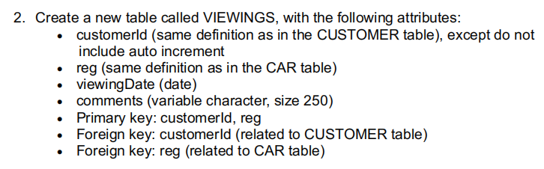

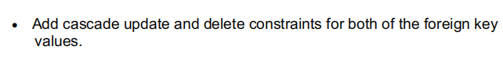

**Solution:**

**Code:** *create table if not exists viewings(*

*customerId int not null,*

*reg varchar(15) not null,*

*viewingDate date,*

*comments varchar(250),*

*primary key(customerId, reg),*

*constraint fk_customer foreign key(customerId) references customer(customerId),*

*constraint fk_car foreign key(reg) references car(reg)*

*on update cascade*

*on delete cascade*

*);*

**Output:**

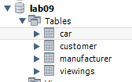

#### Problem 3:

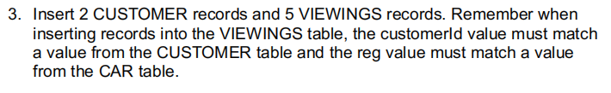

**Solution:**

**Code:** *insert into customer(fName,lName,emailAddress)*

*value('Ziheng','Wang','123456@qq.com'),*

*('Kaifengg','Jin','23456@q q.com');*

**Output:**

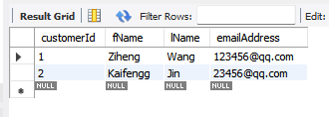

**Code:**  *insert into viewings(customerId,reg)*

*value('1','08-KK-1234'),*

*('1','10-WX-9875'),*

*('2','141-KK-345'),*

*('2','11-WD-1876'),*

*('2','12-WX-222');*

**Output:**

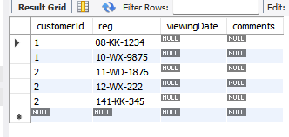

#### Problem 4

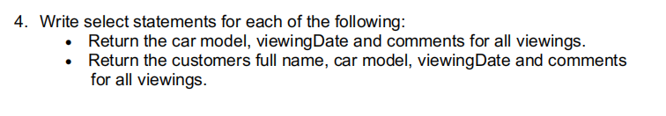

**Solution:**

**Code:** *select MODEl, viewingDate, comments*

*from viewings*

*join car*

*on car.reg=viewings.reg;*

**Output:**

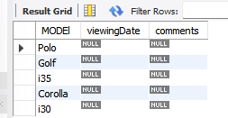

**Code:**  select concat(fName,lName) as 'fullName', MODEl, viewingDate, comments

from viewings

join car

on car.reg=viewings.reg

join customer

on viewings.customerId=customer.customerId;

**Output:**

